**2.2 Midpoint Do Now**

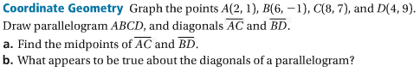



**Coordinate Geometry** Graph the points *A*(0, 0), *B*(3, 3), *C*(9, 3), and *D*(12, 0).

Draw trapezoid *ABCD* and diagonals and*.* Add point *E*(6, 2) at the intersection of diagonals ** and *.*

**a.** Find *BE* and *CE*. What do you notice?

**b.** Find *AE* and *DE*. What do you notice?

**c. Make a Conjecture** What appears to be true about the diagonals of a trapezoid?

